Select ASP.NET web framework:

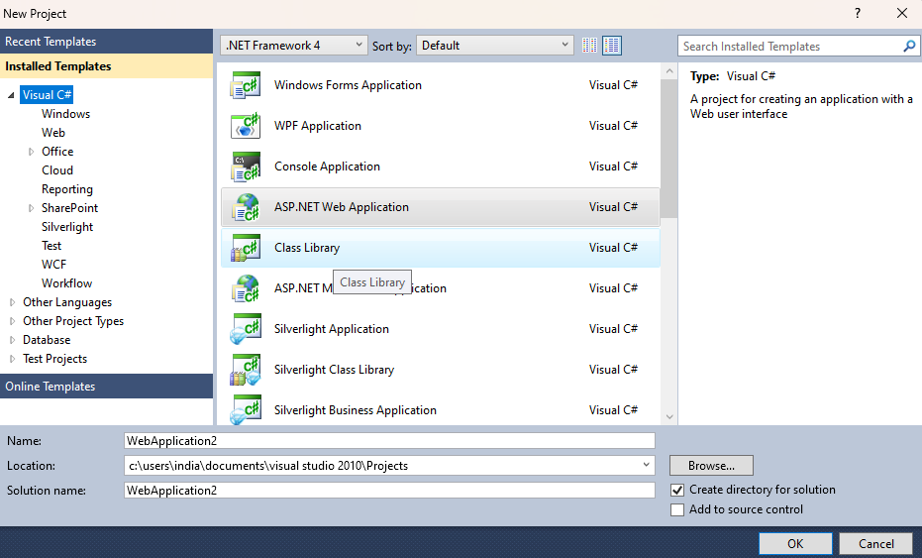

Add Web service:

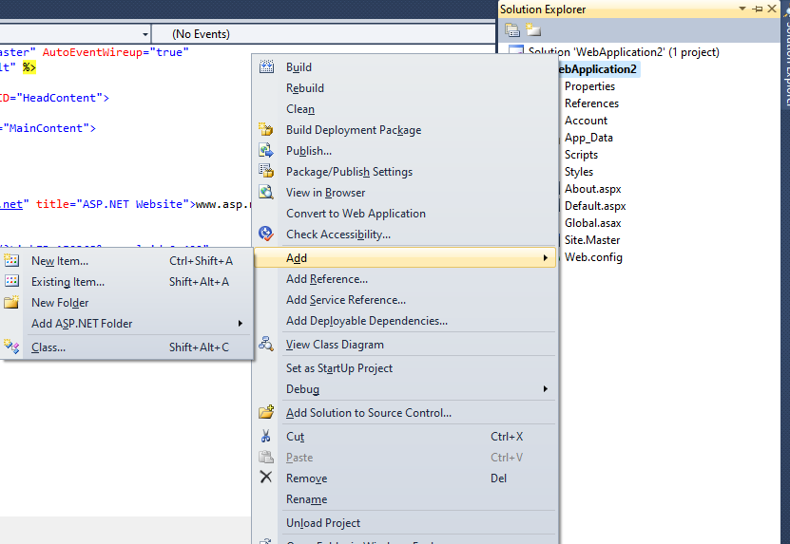

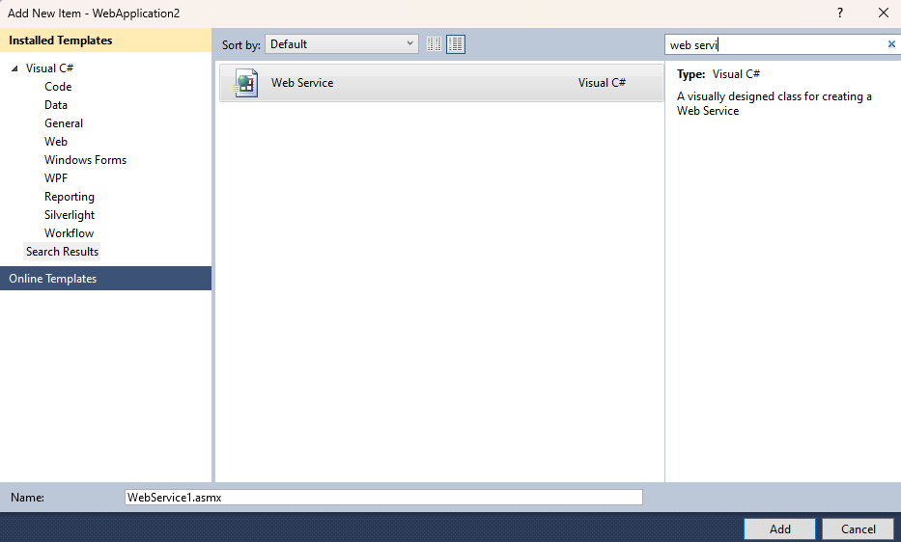

**Code of Webservice.asmx.cs:**

using System;

using System.Collections.Generic;

using System.Linq;

using System.Web;

using System.Web.Services;

using System.ComponentModel;

namespace WebApplication2

{

/// <summary>

/// Summary description for Practical_MTOM

/// </summary>

[WebService(Namespace = "http://tempuri.org/")]

[WebServiceBinding(ConformsTo = WsiProfiles.BasicProfile1_1)]

[System.ComponentModel.ToolboxItem(false)]

// To allow this Web Service to be called from script, using ASP.NET AJAX, uncomment the following line.

// [System.Web.Script.Services.ScriptService]

public class Practical_MTOM : System.Web.Services.WebService

{

[WebMethod]

public string HelloWorld()

{

return "Hello World";

}

[WebMethod, Description("Get image content")]

public byte[] GetImageFile(string filename)

{

if (System.IO.File.Exists(Server.MapPath("~/Images/") + filename))

{

return System.IO.File.ReadAllBytes(Server.MapPath("~/Images/") + filename);

}

else

{ return new byte[] { 0 };}}}}

Add handler

Solution explorer -- Add -- new item -- Generic Handler --Give name -- Add

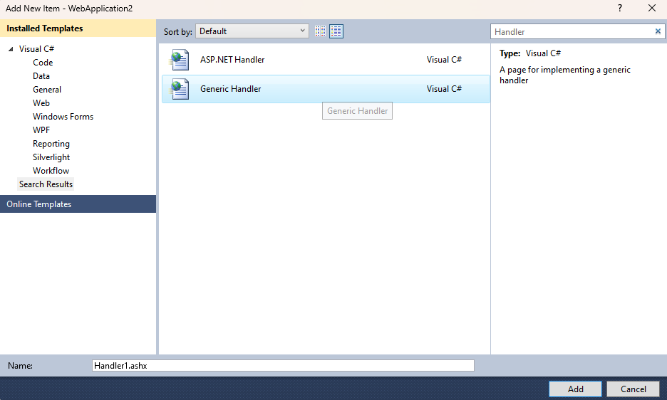

**Code myHandler.ashx.cs:**

using System;

using System.Collections.Generic;

using System.Linq;

using System.Web;

namespace WebApplication2

{

/// <summary>

/// Summary description for myHandler

/// </summary>

public class myHandler : IHttpHandler

{

public void ProcessRequest(HttpContext context)

{

Practical_MTOM ws = new Practical_MTOM();

byte[] binImage = ws.GetImageFile(context.Request["fileName"]);

if (binImage.Length == 1)

{

}

else

{

context.Response.ContentType = "image/jpeg";

context.Response.BinaryWrite(binImage);

}

}

public bool IsReusable

{

get

{

return false;

}

}

}

}

Same Add one web form

Solution explorer -- Add -- new item -- Web form -- Give name -- Add

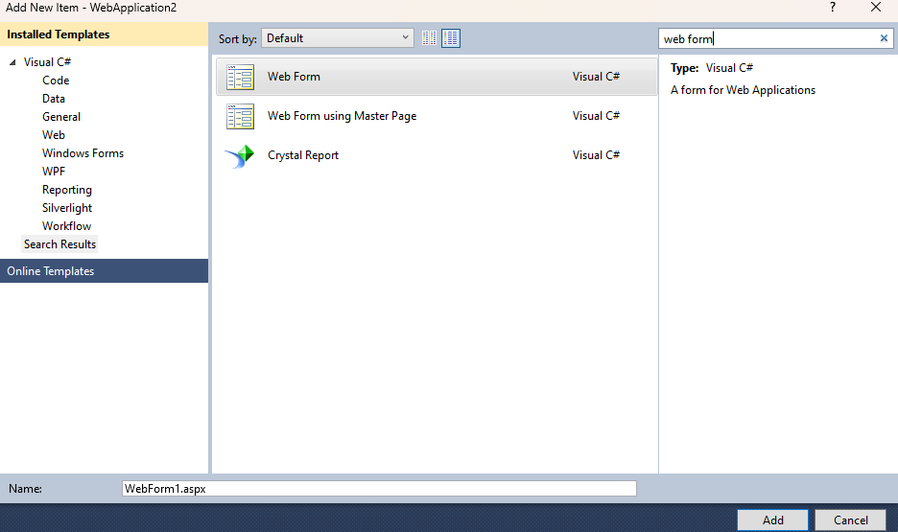

Add buttons, textboxes using drag and drop:

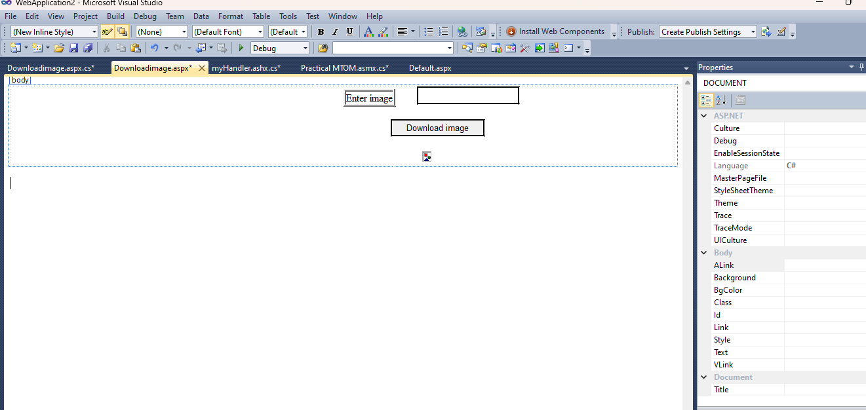

**Code DownloadImage.aspx.cs (Web form):**

using System;

using System.Collections.Generic;

using System.Linq;

using System.Web;

using System.Web.UI;

using System.Web.UI.WebControls;

namespace WebApplication2

{

public partial class Downloadimage : System.Web.UI.Page

{

protected void Page_Load(object sender, EventArgs e)

{

}

protected void btn1_click(object sender, EventArgs e)

{

Image1.ImageUrl = "~/myHandler.ashx?fileName=" + txt1.Text;

Response.Write("Downloading of Image is done");

} } }

Creating a folder and copying images:

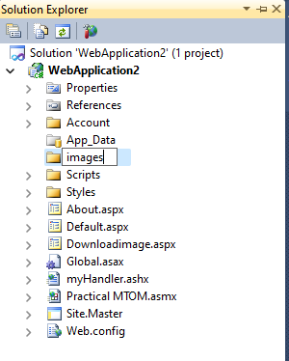 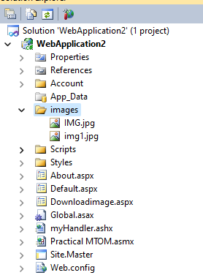

Open the web form in browser:

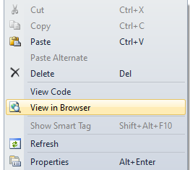

**Output:**

